# Intro to Visual Studio

Welcome to this Visual Studio 2015 tutorial! I bet you’re wondering why you should choose this awesome IDE? I’ll give you the breakdown on why you should be programming with is IDE.

Have I downloaded this program? Check! Do I have c++ libraries installed? Check! Am I prepared to have my mind blown from the awesomeness of Visual Studio? Check! If you haven’t completed the first two all you need to do is download it at <https://www.visualstudio.com/en-us/downloads/download-visual-studio-vs.aspx> and select the community version and install it once the download is complete. If number 3 doesn’t check out? Then this isn’t the IDE you are looking for.

Now you are ready to create a new project. Open visual studio and click on “New Project”

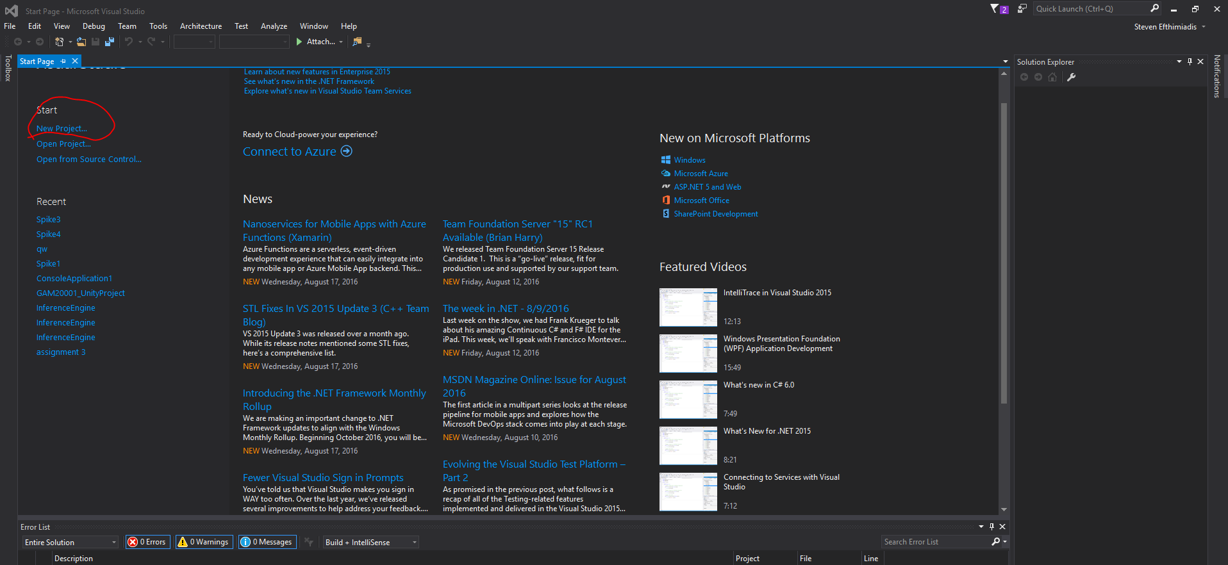

Now select “Visual C++”, select “Win32 Console Application” and select the name of the program.

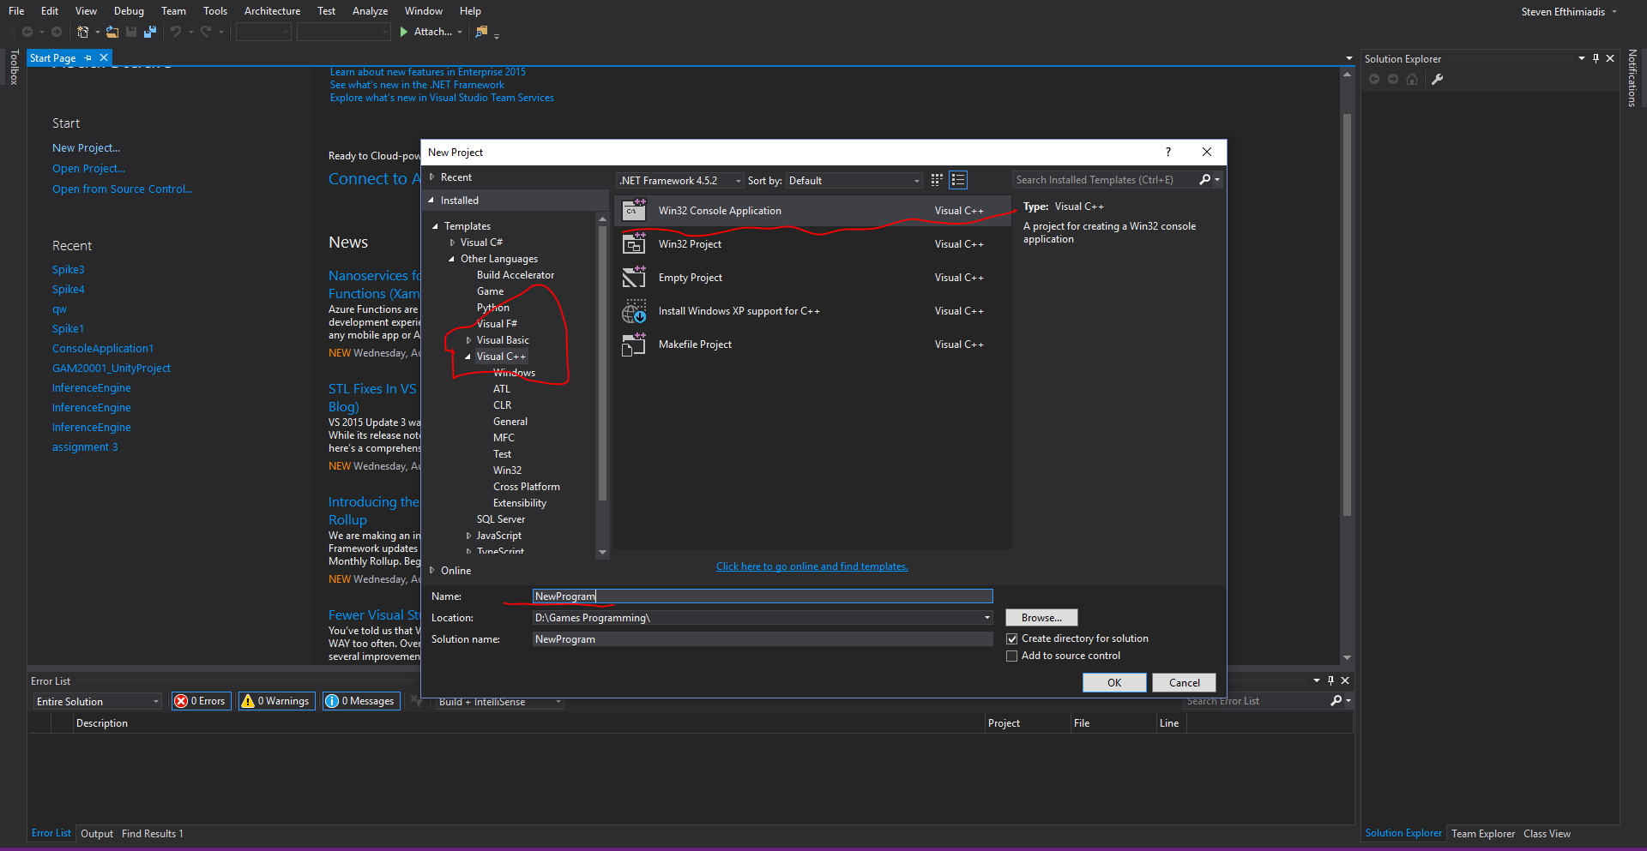

Now you are wondering that you haven’t installed the c++ libraries and you are panicking? Don’t worry bro/ sis Visual Studio has your back and it will prompt you to install them!

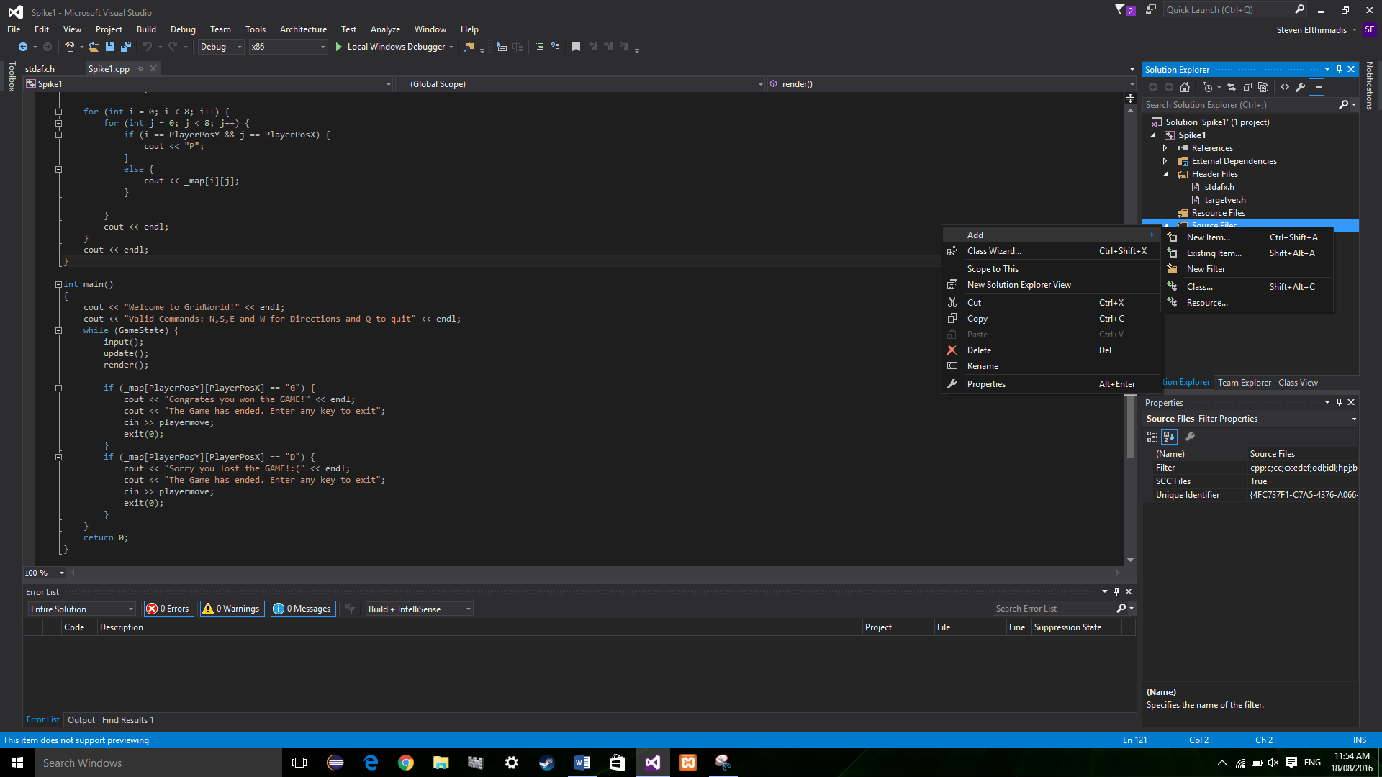Now you have a new c++ project let us make a new file. Firstly right click the Source File folder and then select Add. The click new item.

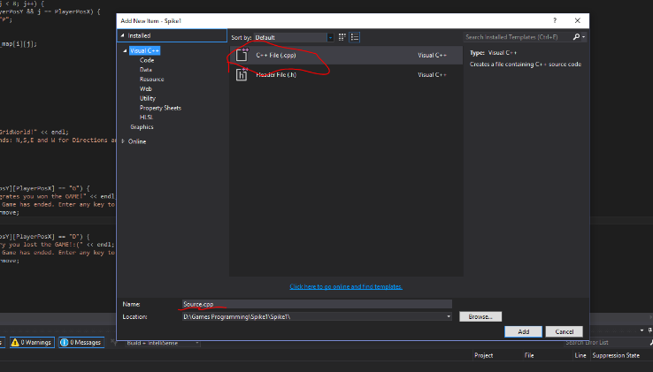

Then you select C++ file and change the name and click add.

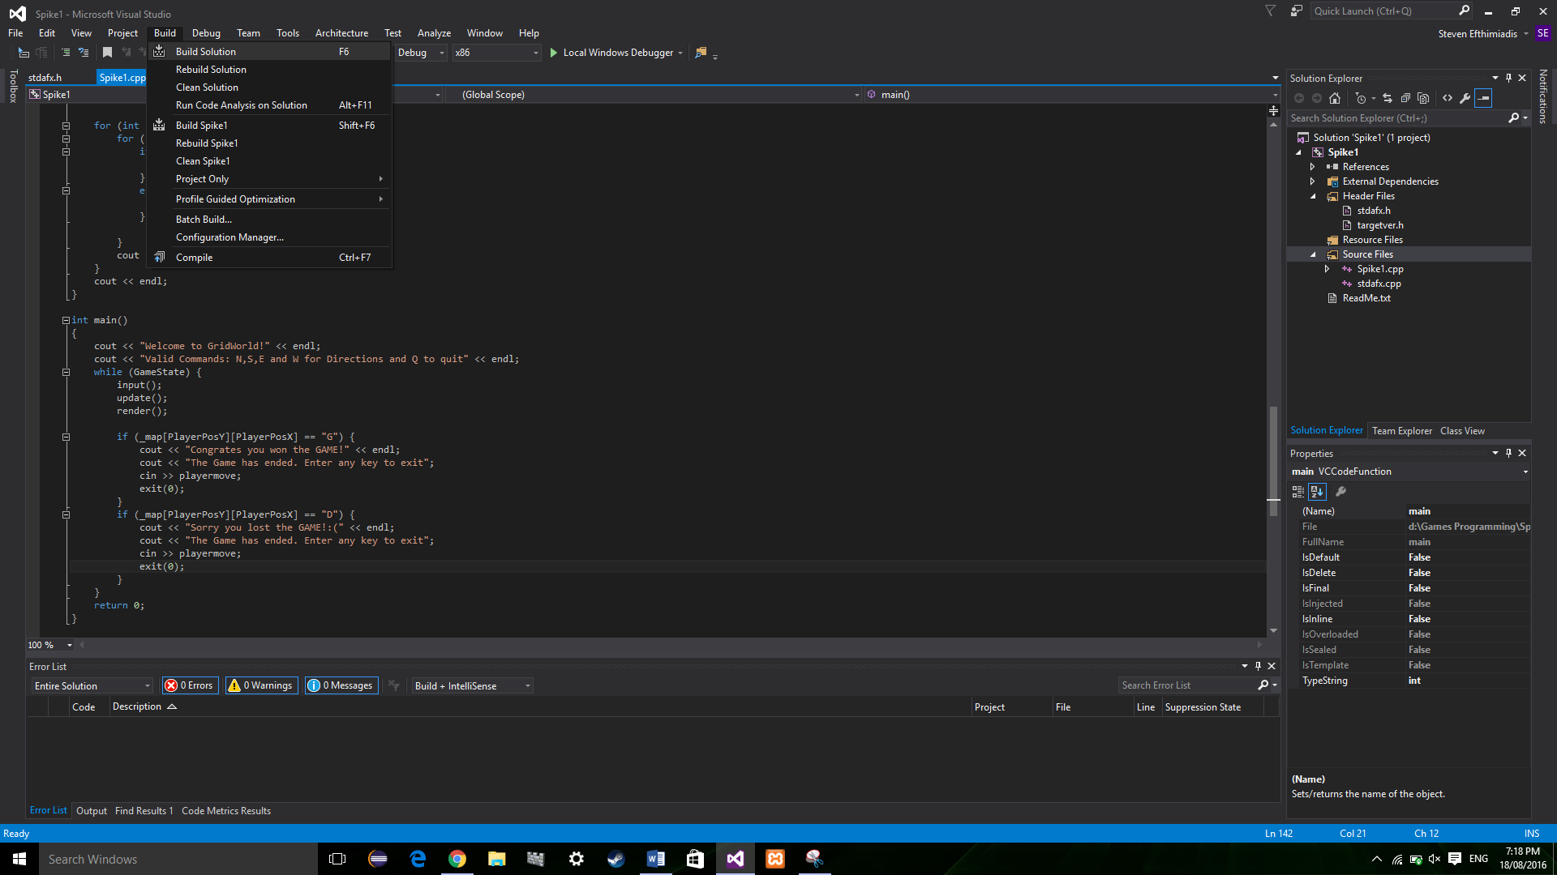

Now if you want to build and run the solution all you need to do is go to the build tab and select build solution or the easy way is to click the play button next to Local Windows Debugger.

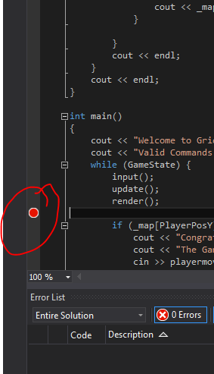

Now you wish to make a break point so you can see how your program changes after each step. There is a light grey bar next to the coding section where you click and a red dot will appear. This means you have created a break point.

So if you don’t know what a breakpoint is it a point in the code you wish to pause the program at during runtime to see if the functionality of the code is working.

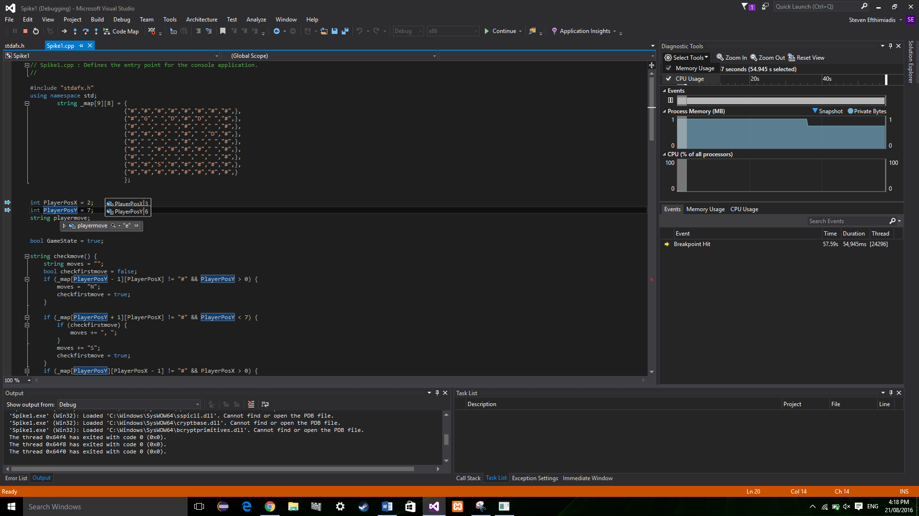Now if you have the debugger open and hover over a variable, you can see if they have changed. Then if you select the pin, it will permamently stay on the screen while the debugger is on.

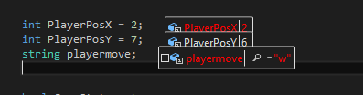Now when the variable changes, you will notice it if you pinned the variable on the screen.

Now these are the basics you need to know to start creating programs with Visual Studio. There are more features of the program but as a beginner, you start small and as you start to understand how Visual Studio works you can start using libraries that help with debugging.